Nabeel Ahmed
D214 Task 1 Performance Assessment
10/27/2025

- Research Question:
  - The research question for this project is:
To what extent do vehicle characteristics—specifically engine horsepower, number of cylinders, and fuel efficiency—affect a car’s market price (MSRP)?
This question is relevant because MSRP varies widely across vehicles, and identifying which technical specifications most strongly influence price can help manufacturers with pricing strategy and help consumers make informed purchasing decisions. The analysis uses real automotive market data, making the findings practical and applicable to real-world decision-making.
The study is guided by the following hypotheses:
    - Null Hypothesis (H₀): Vehicle characteristics do not have a statistically significant effect on MSRP.
    - Alternative Hypothesis (H₁): At least one vehicle characteristic has a statistically significant effect on MSRP.
A multiple linear regression model will be used to quantify the relationship between vehicle characteristics and MSRP and determine how much variation in price can be explained by these predictors.
- Data Collection:
  - The data used in this project was collected from a publicly available automobile dataset titled “Car Features and MSRP” on Kaggle. The dataset contains 11,914 vehicle records with 16 attributes, including specifications such as make, model, engine horsepower, number of cylinders, fuel efficiency (city and highway mpg), and MSRP. The dataset was downloaded in CSV format and imported into Python for analysis.
An advantage of using this dataset is that it is publicly accessible and widely used in academic and data science projects, making the analysis reproducible and transparent. A disadvantage is that the dataset was not created specifically for this study, and it contains missing or inconsistent values, particularly in categorical fields such as fuel type and transmission. During the data preparation process, these inconsistencies were addressed by focusing the analysis on reliable numerical variables and removing unusable or incomplete data. Initial exploratory checks were also performed to ensure the dataset was suitable for regression analysis.
- Data Extraction and Preparation:
  - The dataset was downloaded from Kaggle as a CSV file and imported into Python for cleaning and preparation. Pandas was used for data extraction and transformation due to its ability to efficiently manipulate tabular data. The process is summarized below and screenshots of each step are included in the appendix.
  - Data Extraction:
    - The dataset was loaded into a pandas DataFrame using read_csv().
    - The .head(), .info(), and .isna().sum() functions were used to inspect the data structure and identify missing values.
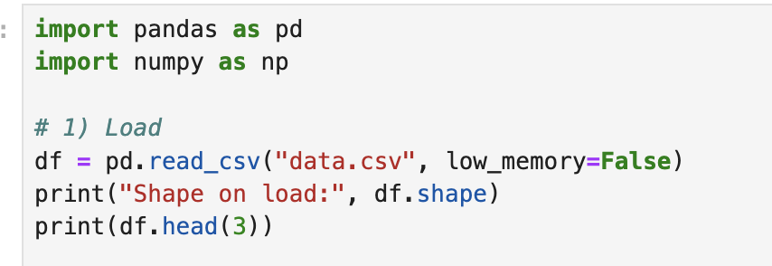
  - Data Cleaning:
    - Duplicate records were removed using .drop_duplicates() to prevent skewing the analysis.
    - Rows missing the target variable (MSRP) were removed because they could not be used in regression modeling.
    - The predictor variables Engine HP, Engine Cylinders, city mpg, and highway MPG were converted to numeric types using pd.to_numeric to ensure compatibility with statistical modeling.
    - Missing numeric values were imputed using the median, which prevents distortion from extreme values compared to mean imputation.
(Complete guide to data cleaning in Python)
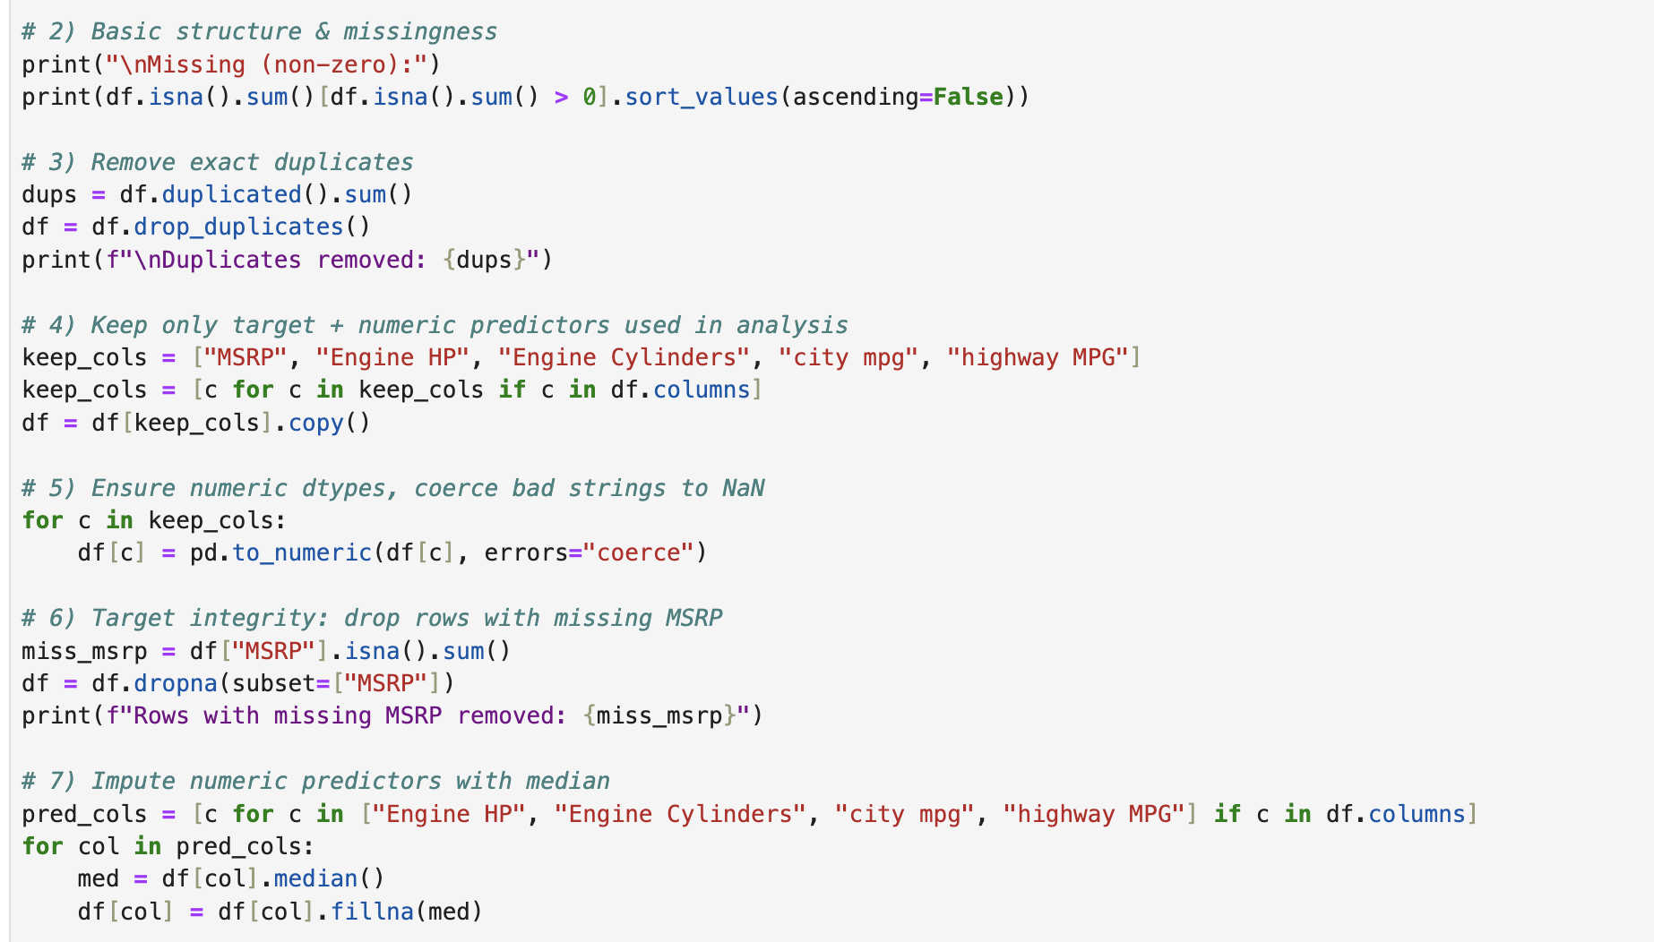
  - Feature Preparation:
    - An outlier check for MSRP was conducted using the interquartile range (IQR) method. Outliers were retained to preserve realistic pricing variability in the dataset.
    - Categorical fields such as fuel type and transmission type were initially considered but excluded from the model due to inconsistent formatting and missing values, which reduced model stability.
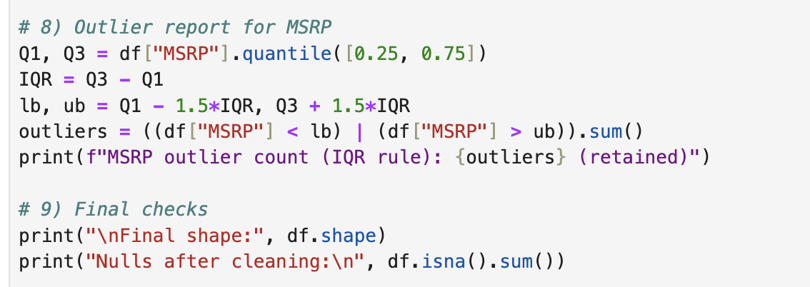
  - Output:
    - The final cleaned dataset was saved as ‘cars_cleaned.csv’ for regression analysis in Section D.
  - Tools and Justification:
    - Python and pandas were used for reproducibility, transparency, and scalability in data preparation.
    - Median imputation was chosen because it is resistant to skew and outliers.
    - Advantage: This process created a clean, analysis-ready dataset while maintaining data integrity.
    - Disadvantage: Excluding categorical variables may reduce model completeness, but this limitation is acknowledged and addressed in Section E as an opportunity for future analysis.
- Analysis:
  - The data was analyzed using multiple linear regression to measure the impact of vehicle characteristics on MSRP. The model included four numeric predictors: Engine Horsepower (HP), Engine Cylinders, city mpg, and highway MPG. Regression was performed in Python using the statsmodels library. The model produced an Adjusted R² of 0.451, meaning that 45.1% of the variation in MSRP is explained by these predictors. All predictors were statistically significant (p < 0.001) and had positive coefficients: for example, Engine HP increased MSRP by $317.08 per unit, and each additional engine cylinder increased MSRP by $6,680.55. A Variance Inflation Factor (VIF) test showed multicollinearity among predictors (VIF range: 15.7–34.3).
(Multiple linear regression using Python – ML)
A one-way ANOVA was also performed to compare MSRP across different levels of engine horsepower, and results were significant (p < 0.001), confirming that MSRP varies based on engine power. Multiple linear regression was selected because it allows for analyzing the combined impact of several predictors on a continuous outcome. ANOVA was used as a supplementary method to validate differences between groups. An advantage of these techniques is that they provide interpretable statistical evidence. A disadvantage is that regression assumes linearity and is affected by multicollinearity, which was detected and acknowledged as a model limitation. (Python for data science)
- Data Summary and Implications:
  - The results of the data analysis show that vehicle characteristics have a significant effect on a car’s market price (MSRP), answering the research question. The regression model revealed that engine horsepower and number of cylinders are the strongest predictors of MSRP, while fuel efficiency (city and highway mpg) also contributes but to a lesser extent. This indicates that performance-related features have a greater impact on vehicle pricing than fuel economy.
One limitation of the analysis is that multicollinearity was present among predictors, as indicated by high VIF values. This may reduce the reliability of individual coefficient estimates. Additionally, some categorical features were excluded due to missing or inconsistent data, which may limit the model’s completeness.
Based on the findings, it is recommended that manufacturers and dealerships consider engine specifications as key pricing factors when setting market prices, and consumers can use horsepower and cylinder count as strong indicators of vehicle price when comparing options.
For future study, it is recommended to:
    - Include cleaned and encoded categorical variables such as transmission type, vehicle size, and fuel type to improve model accuracy.
    - Test additional modeling approaches, such as polynomial regression or tree-based models, to capture potential nonlinear relationships in vehicle pricing.
- Sources:
Complete guide to data cleaning in Python. Dataquest. (2024, December 9). https://www.dataquest.io/guide/data-cleaning-in-python-tutorial/
Multiple linear regression using Python - ML. GeeksforGeeks. (2025, July 11). https://www.geeksforgeeks.org/machine-learning/ml-multiple-linear-regression-using-python/
Python for data science. One-way ANOVA with Python. (n.d.). https://www.pythonfordatascience.org/anova-python/

